Street Games - Tech Spec

Production Communications
For all programming and producing communications please, email johnny@autindt.co.uk and cc annalise@autindt.co.uk

The company tours with 3 games hosts, 1 stage manager, 2 DJs and up to 2 BSL Interpreters. We will require up to 3 parking spaces. (8 people on the road)

Show duration
Playing time approx. 60-minutes (45-minutes Street Games + 15-minutes DJ music set)

The company can perform the full show up to a maximum of 3 times per show day, with a minimum of 90 mins between the end of 1 performance and the start of the next one. (Suggested programming showtimes are 11:30am, 2pm & 4:30pm)

Minimum playing space (flexible): A flat, even surface (for example: public square, park). 6m x 7m (depending on expected numbers of participants). We are self-contained. We can actively engage up to 200 participants at a time and more participants would require a larger space than the minimum required.

Get-in/get-out Time
- The company requires a minimum of 45-minutes to get-in for music set up, warm up and prep before the first performance.
- The Company requires a minimum of 45 minutes allowed to get-out, pack the music, props, and load the car/van.

Venue
- The company requires 2 x Loud Speakers and 3 x Lapel Mics for the DJ set up and Game Hosts.
- The company requires access to power to charge electrical devices (laptops, DJ kit etc.)
- The company provides props for audience use (colourful bandanas, storage buckets, and long pieces of fabric). The company requires tables for a DJ booth at the total measurements of 3 metres long x 1.5 metres high.
- The company requires a minimum of 1 dressing room / indoor changing space.
- The company requires barriers/fencing/rope (flexible with material) to be pre-set before arrival to delaminate the performance space.

Sound
- The sound is controlled via our 2 DJs (EIF Sound and Music) for which we require a minijack connection.

Note on Weather
- The performances can be performed under light rain and mild wind.

Easy Read Information

- The company will provide an Easy Read Information Pack to be distributed and marketed by both the company and the festival. Date, Times, and Location to be added when confirmed. Please see an example here.

Images for reference

DJ set up with booth from Birmingham Pride 2022.

2 long pieces of fabric used for one of the games.

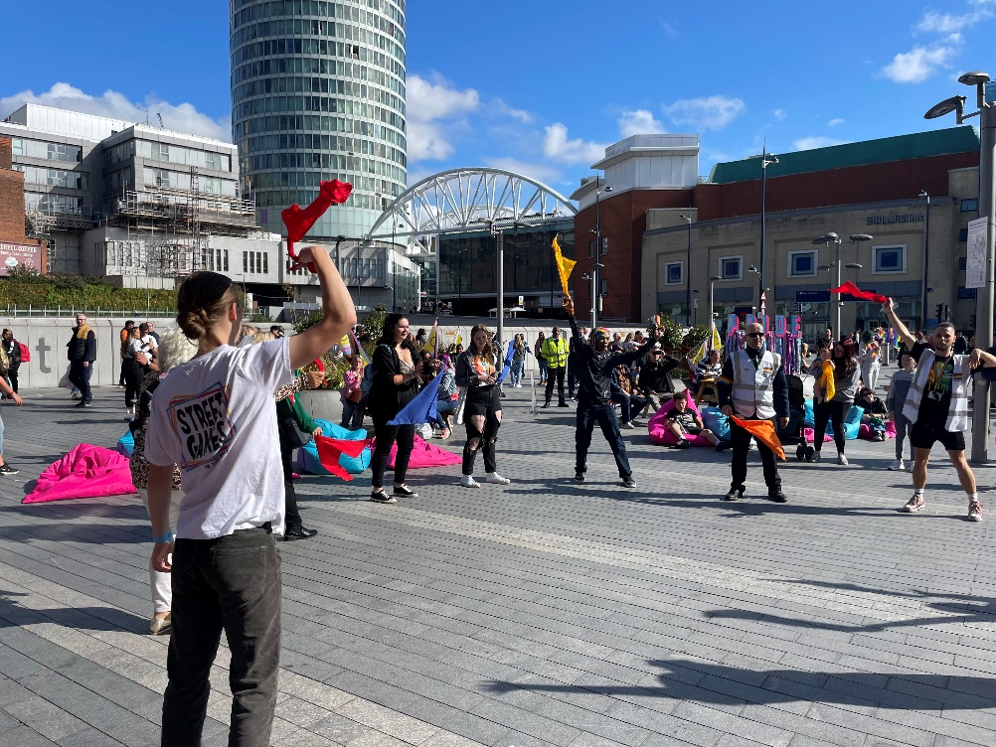
Colourful bandanas used for audience participation.

Contacts
Creative Director - Johnny Autin - johnny@autindt.co.uk - 07557 981497
Associate Producer – Annalise McIntyre – annalise@autindt.co.uk - 07528 157151

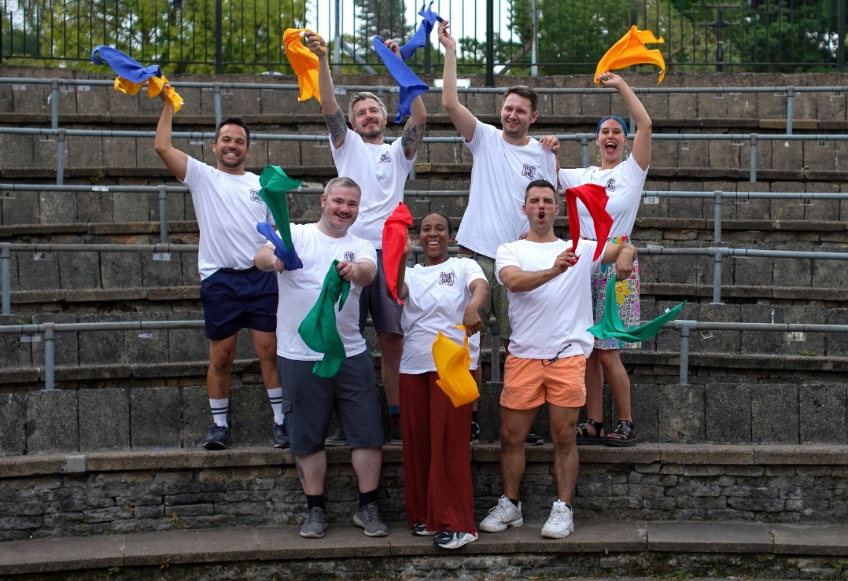

Thank you for your time and interest,

All the best,
The AutinDT Team

